**Windows Service Monitoring**

This article was updated to support v11.7.8 of Goliath Performance Monitor.

Windows Services Watch rules monitor Windows Services on your Windows servers/workstations using our Goliath Intelligent Agent to alert on specified conditions in real-time.

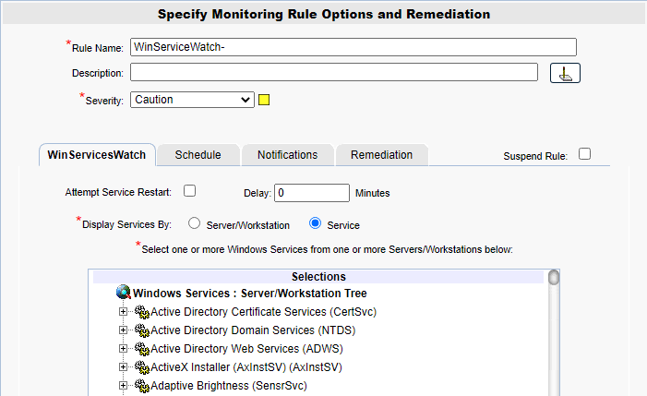

**Configure the Monitoring**

1. To create a new monitoring condition for a Windows Service, navigate to the **Configure - Monitoring Rules** page and click the **New** button
2. A selection pane will appear, select the radio button option for **WindowsServices Watch** and then click **OK**
3. Now the monitoring rule pane will appear. At the top of the pane name the Monitoring Rule via the **Rule Name** field, as well as define the description and the severity.
4. The first tab, **WinServicesWatch** is where you will define what Windows Service the rule is monitoring.
   1. If you would like to configure the remediation action of attempting to restart the service if it is stopped, select the checkbox in the ‘Attempt Service Restart’ field.
   2. In the optional ‘Delay’ field, add a duration that the service must be stopped for in order to trigger and alert.
   3. In the ‘Display Services By’ field, choose how you’d like to sort the ‘Selection’ tree. If ‘Server/Workstation’ is chosen, the tree will be sorted via the primary groups defined in the product. If ‘Service’ is selected, the tree will be sorted by the Windows Services detected.
   4. Use the ‘Selections’ tree to define which Windows Service you’d like to monitor and on which servers/workstations you’d like to monitor it on.

**Configure the Schedule**

The **Schedule** tab of a monitoring rule allows users to define how frequently the rule will alert. This can be done by adjusting the following fields:

* **Alert Every Time**: Defines whether an alert is generated every time the conditions are on the previous tab are met.
  + When checked the alert is generated every time the conditions are met.
  + When unchecked, the alert is only generated if the alert conditions are met, and the Minimal Notification Interval is exceeded since the last alert for this type.
* **Minimal Notification Interval**: Defines the minimal interval that must elapse between events for this alert before another alert will be generated.
  + The Alert Every Time checkbox must be unchecked in order to use this option.
  + For ServerWatch IP Services, this also defines the minimum elapsed time since a service is first detected as down or failed before an alert is generated.
* **Maximum Notification Interval**: Defines the maximum number of times you want to be notified during a continuous failure situation.
  + A value of 0 means no maximum is defined so you will continue to be notified according to your Alert Every Time and Minimal Notification Interval settings.
  + A non-zero value means that after you have been notified the number of times defined in the Maximum Alert Notifications, and according to your Alert Every Time and Minimal Notification Interval settings, you will not be notified again.
* **Notify On Restore**: Defines whether a 'Restore' alert is generated if you have previously been alerted due to a failure.
  + There is always a Notify on Restore for a ServerWatch for IP Service
* **Active Only if Server 'Owns".... This Cluster Group**: This option is for monitoring machines that are apart of a cluster. If the checkbox is checked, then the rule is monitoring and will alert only if the server is a member of a cluster, 'owns' the specified Cluster Group and the specified Cluster Group is 'Online'.

**Additional Configuration**

For additional configuration options please see the following articles:

* Enabling Notifications:
  + [Configure Email and Text Alert Notifications](https://support.goliathtechnologies.com/hc/en-us/articles/360024446933)
  + [Configure SNMP Alert Notifications](https://support.goliathtechnologies.com/hc/en-us/articles/360024726913)
  + [Configure Syslog Alert Notifications](https://support.goliathtechnologies.com/hc/en-us/articles/360024346594)
* [Configure Custom Remediation](https://support.goliathtechnologies.com/hc/en-us/articles/360024446633)